Music development plan summary:
Ightham Primary School

Overview
Detail | Information
Academic year that this summary covers | 2025-2026
Date this summary was published | January 2026
Date this summary will be reviewed | September 2026
Name of the school music lead | James White
Name of school leadership team member with responsibility for music (if different)
Name of local music hub | Kent Music
Name of other music education organisation(s) (if partnership in place)

This is a summary of how our school delivers music education to all our pupils across three areas – curriculum music, co-curricular provision and musical experiences – and what changes we are planning in future years. This information is to help pupils and parents or carers understand what our school offers and who we work with to support our pupils’ music education.

Part A: Curriculum music
This is about what we teach in lesson time, how much time is spent teaching music and any music qualifications or awards that pupils can achieve.
‘Music is a universal language that embodies one of the highest forms of creativity.’ – The National
Curriculum.
At Ightham Primary School, we aim to ensure we are providing a musical curriculum that allows all children the opportunity to experience and enjoy music. They develop the skills outlined in the National Curriculum and their knowledge of musical cultures and developments from across the globe.
Music is taught from weekly from Reception to Year 6 by the class teacher using the Kapow scheme of work with additional opportunities for cross-curricular links throughout the school.

Aim:
The National curriculum for music states that the aims for Music education in Primary Schools are:
• For children to have the opportunity to perform, listen to, analysis and evaluate music from across a range of historical periods, genres, styles and traditions, including studying the works of great composers and musicians.
• Children to learn to sing, to have the opportunity to play and learn a musical instrument, to compose their own pieces of music independently and within a group and to use technology appropriately to enhance their own compositions and to learn how to edit and manipulate music.
• For children to develop an understanding of how music is created, produce and communicated using the inter-related musical dimensions: pitch, duration, dynamics, tempo, timbre, texture, structure and appropriate musical notations.

Scheme of Curriculum
Ensuring the high quality of teaching of music is a priority at Ightham Primary School and therefore, we have the Kapow scheme of work to ensure clear progression and learning in an integrated, practical, exploratory and child-led approach.
The curriculum focuses on ensuring all children develop the skills, knowledge and understanding needed to become confident performers, composers and listeners. By exposing the pupils to a wide range of music from around the world and across generations, their knowledge is further developed and allows them to appreciate and build respect for different cultures, traditions, and communities. The curriculum enables pupils to reach the end of key stage attainment targets outlined in the National Curriculum, including performing, listening, composing, the history of music and inter-related dimensions of music: pitch, duration, dynamics, tempo, texture, structure, timbre.

Planning
Each half term, every year group focuses on one of the units of work. Each Unit of Work comprises the of strands of musical learning which correspond with the national curriculum for music:
- Listening and Appraising
- Musical Activities
  - Warm-up Games
  - Singing
  - Playing instruments
  - Improvisation
  - Composition
- Performing
Kapow Units of Work enable children to understand musical concepts through a repetition-based approach to learning. Learning about the same musical concept through different musical activities enables a more secure, deeper learning and mastery of musical skills.

Skills Progression
Over time, the children make progress in the following key areas:
- Listening and evaluating – expressing musical preferences; exploring the impact of musical ideas; understanding how effects are created by combining musical elements.
- Creating sound – exploring the children’s vocal skills; developing skills to manipulate sounds on a range of instruments.
- Notation – recognising the basics of musical notation; reading simple rhythmic patterns; developing the foundational knowledge of how staff and graphic notations can communicate music.
- Improvising and composing – creating and refining the children’s own music through improvisation and notation; experimenting with styles and features; employing musical concepts to add interest.
- Performing – using voices expressively; developing instrumental control and expression; performing as part of a group.
The curriculum also provides the children the opportunity to develop skills that are transferable across other subjects including: listening skills, teamwork, leadership, creative thinking, problem-solving, decision-making and presentation/ performance skills. These skills support their development as learners and can be applied throughout their lives beyond school.

Assessment
Formative assessment is ongoing and is against the clear lesson objectives. At the end of the year, teachers are required to report for parent’s attainment and effort in Music

Curriculum Overview

 | Autumn 1 | Autumn 2 | Spring 1 | Spring 2 | Summer 1 | Summer 2
EYFS | Exploring sound | Celebration music | Music and movement | Musical stories | Transport | Big band
Year 1 | Keeping the pulse (Theme: My favourite things) | Tempo (Theme: Snail and mouse) | Dynamics (Theme: Seaside) | Sound patterns (Theme: Fairytales) | Pitch (Theme: Superheroes) | Musical symbols (Theme: Under the sea)
Year 2 | Call and response (Theme: Animals) | Instruments (Theme: Musical storytelling) | Singing (Theme: On this island) | Contrasting dynamics (Theme: Space) | Structure (Theme: Myths and legends) | Pitch (Theme: Musical me)
Year 3 | Ballads | Creating compositions in response to an animation (Theme: Mountains) | Developing singing technique (Theme: the Vikings) | Pentatonic melodies and composition (Theme: Chinese New Year) | Jazz | Traditional instruments and improvisation (Theme: India)
Year 4 | Body and tuned percussion (Theme: Rainforests) | Rock and roll | Changes in pitch, tempo and dynamics (Theme: Rivers) | Haiku, music and performance (Theme: Hanami festival) | Samba and carnival sounds and instruments (Theme: South America) | Adapting and transposing motifs (Theme: Romans)
Year 5 | Composition notation (Theme: Ancient Egypt) | Blues | South and West Africa | Composition to represent the festival of colour (Theme: Holi festival) | Looping and remixing | Musical theatre
Year 6 | Dynamics, pitch and texture (Theme: Coast) | Songs of World War 2 | Film music | Theme and variations (Theme: Pop Art) | Baroque | Composing and performing a Leavers’ song

Part B: Co-curricular music
This is about opportunities for pupils to sing and play music, outside of lesson time, including choirs, ensembles and bands, and how pupils can make progress in music beyond the core curriculum.
The school offers a range of music tuition including piano, guitar, brass, string and woodwind instruments. These are taught on a one to one basis by peripatetic teachers.
We offer extra-curricular opportunities for children; both Key Stage 1 and Key Stage 2 have the opportunity to join a choir as an after school club. Will also offer a Key Stage 2 Drama Club which includes singing and performing arts.
To further enhance the musical enrichment at Ightham Primary School, the children are provided with a Pupil Passport, which ensures that by the end of Key Stage 2 they should have learnt how to play an instrument and have the opportunity to take part in a live show.
To enhance the development of singing technique across the school, we have a weekly singing assembly for all children. Across each phase the children learn to play instruments such as the ocarina, recorders and handbells.
The school also accesses Sing Up through Kent Music. The subscription is used to enhance the singing assemblies.

Part C: Musical experiences
This is about all the other musical events and opportunities that we organise, such as singing in assembly, concerts and shows, and trips to professional concerts.
Musical Events and Performances
• Singing assemblies
• End of term Music Recital
• Harvest Church Service performances
• Christmas Church Service performances
• Easter Church Service performances
• Reception Christmas performance
• Key Stage 1 Christmas performance
• Year 6 – End of year show
• Carol Singing in the community, including Community Coffee Morning and at Ightham Mote
• Workshop with Sevenoaks School

In the future
This is about what the school is planning for subsequent years.
- Music Action Plan
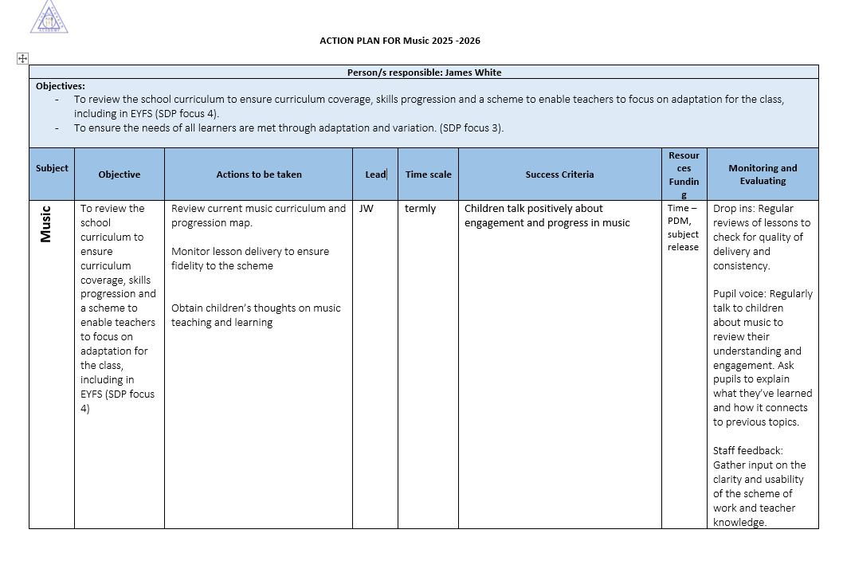
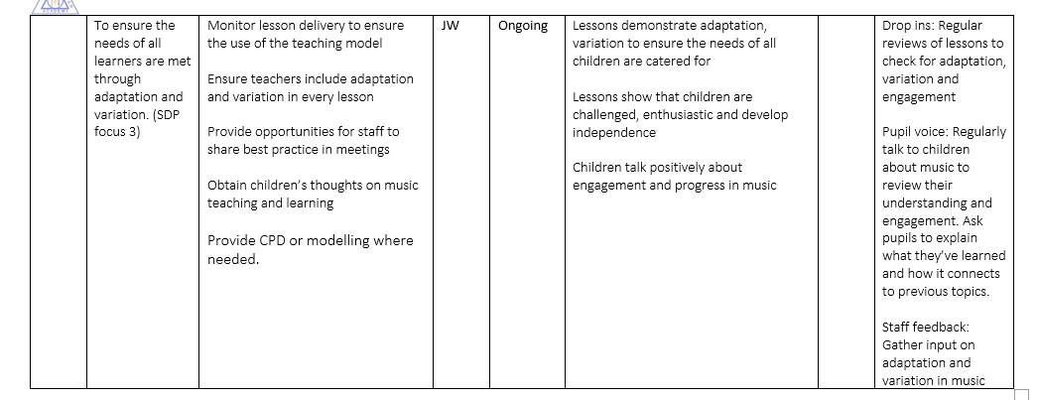

Further information (optional)

